

**Movie Maniac**

Team: Movie Maniac

Member:

Phuong Linh Pham      (300923800)

Minseok Choi (300917184)

Contents

Description 2

Project Structure 3

Design 4

Wireframe 4

DB structure 10

# Description

The Movie Maniac is a web app of user’s movie collection that allows user to review, rent and buy cinema movies or add to their collections. Movie Maniac will track a personal library of movies and display the number of movies in your collection as well as each movie’s details. User can also review and rate for each movie. If they want, they can update and add more details after they have registered.

Link to GitHub repository:<https://github.com/ProNovice/Comp229-TeamAssign>

# Project Structure

MainTracking Page:

1. A form for the registered users to log in and to enter the statistics and data related to the movie in their collection.
2. A form for User Registration. (username, password, email address, phone)
3. A form or control that allows the user to Logout and/or modify his or her profile.
4. Item statistics and data that should be displayed: a. Title b. Picture (of the movie) c. Type d. Review Score e. A link to Detail Page
5. Anonymous users can only view owned movie.

Detail Page:

1. Display all movie details: Title, type, picture, description, review score, completed status, if it is currently owned/loaned/wanted,
2. Link to a page to edit the movie or include that functionality in this page for authorized users
3. Allow to set the movie as owned/wanted/loaned and changing between them
4. Allow members write reviews about the movie
5. Allow members edit movie information
6. Allow members add new movie in the library by linking New movie addition page
7. Anonymous users can only view owned movie

UserRegistration page:

1. Offer the forms to fill UserName, Password, Phone number, Email address.
2. After check validation of input information, and add the new member in Database
3. After registration or cancel, move back to the previous page

UserLogIn page:

1. Offer two forms to fill username and password for Sign-in
2. Check the validation of the input information by comparing with the data in Database
3. After Log-in or cancel, move back to the previous page

AddNewMovie page:

1. This page is linked from Detail page
2. It is allowed to only members
3. After movie addition or cancel, move back to the previous page

# Version of History

V0.1 Project Structure Setup

V0.15 Main page elements were setup, Navigation bar setup

GitHub Commits

V0.1

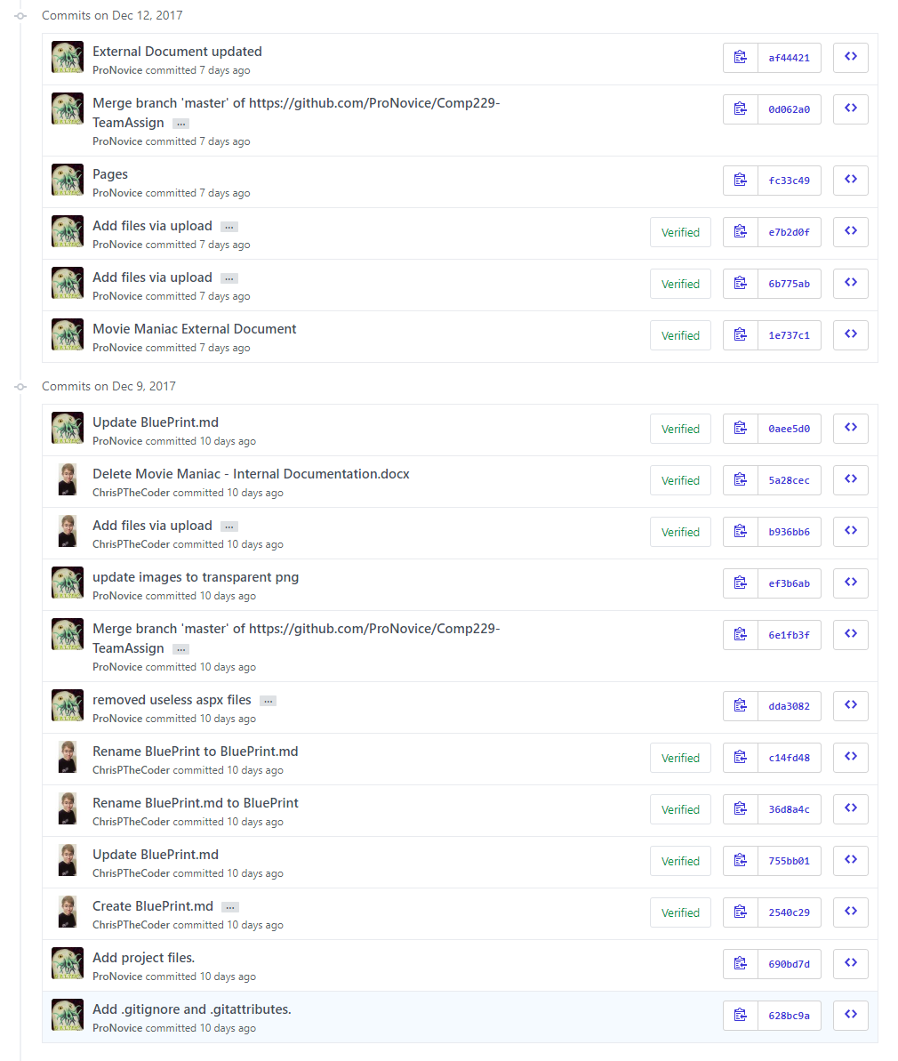

V0.15

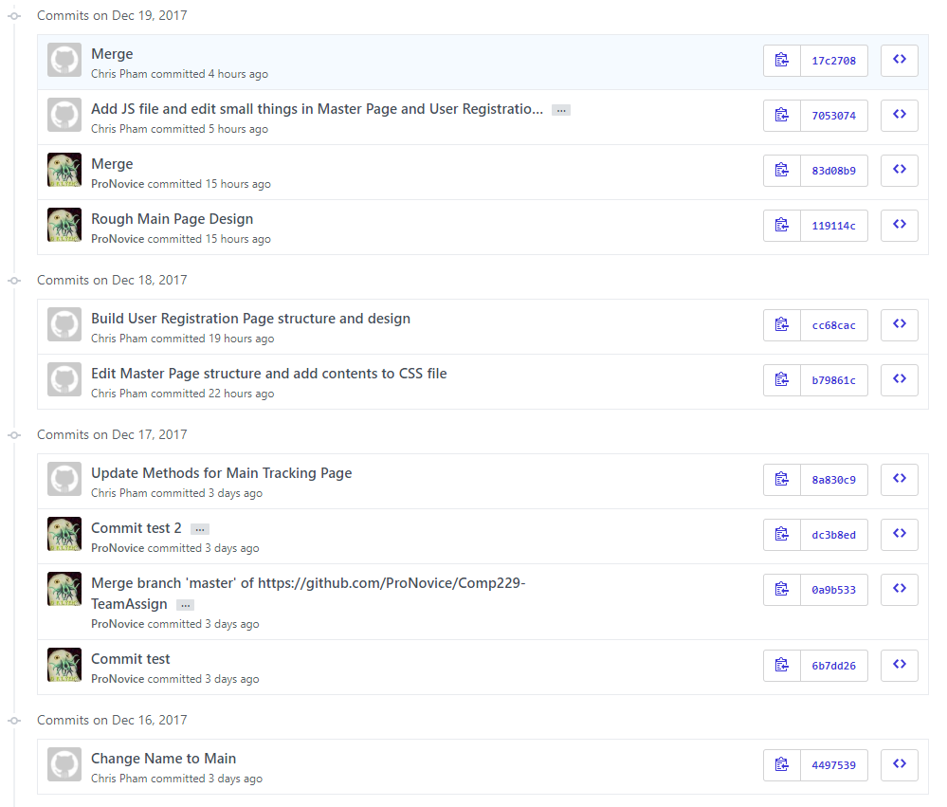

# Design

Font: Dosis

Dosis Font is suitable to express our topic Movie.

This font is stylish and neat, enhancing the readability of the text and the atmosphere.

A​‌B​‌C​‌Ć​‌Č​‌D​‌Đ​‌E​‌F​‌G​‌H​‌I​‌J​‌K​‌L​‌M​‌N​‌O​‌P​‌Q​‌R​‌S​‌Š​‌T​‌U​‌V​‌W​‌X​‌Y​‌Z​‌Ž​‌a​‌b​‌c​‌č​‌ć​‌d​‌đ​‌e​‌f​‌g​‌h​‌i​‌j​‌k​‌l​‌m​‌n​‌o​‌p​‌q​‌r​‌s​‌š​‌t​‌u​‌v​‌w​‌x​‌y​‌z​‌ž​‌1​‌2​‌3​‌4​‌5​‌6​‌7​‌8​‌9​‌0​‌‘​‌?​‌’​‌“​‌!​‌”​‌(​‌%​‌)​‌[​‌#​‌]​‌{​‌@​‌}​‌/​‌&​‌\​‌<​‌-​‌+​‌÷​‌×​‌=​‌>​‌®​‌©​‌$​‌€​‌£​‌¥​‌¢​‌:​‌;​‌,​‌.​‌*

Source: <https://fonts.google.com/specimen/Dosis>

Background color: Black #00000 

Text color: White #ffffff

Main Color: Red Related Color

Logo Color:

Purple(#6c208d) 

Yellow(#ffd92c) 

Bright Purple: #8a008a 

Purple: #4f2453 

Dark Purple: #230022 

# Wireframe

Main page

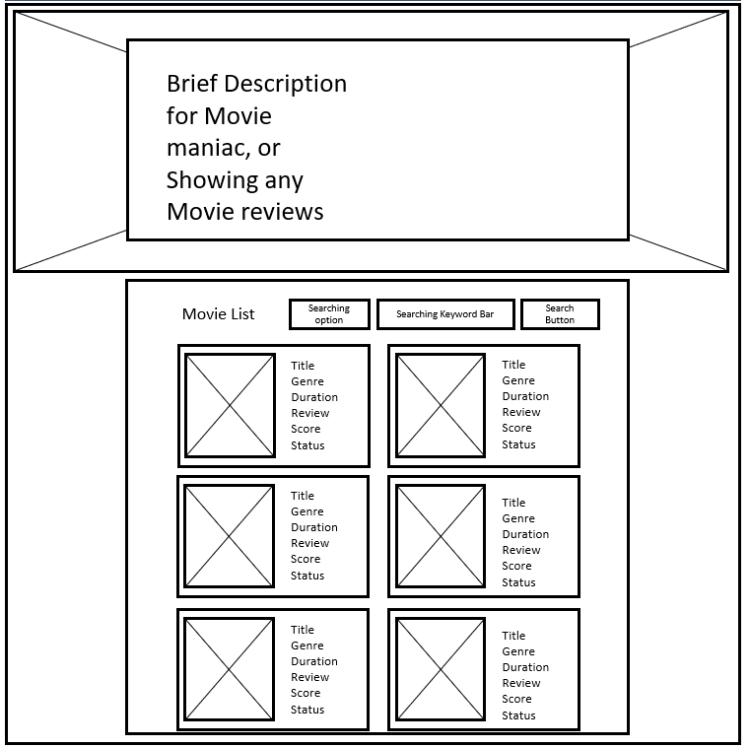

Movie Detail

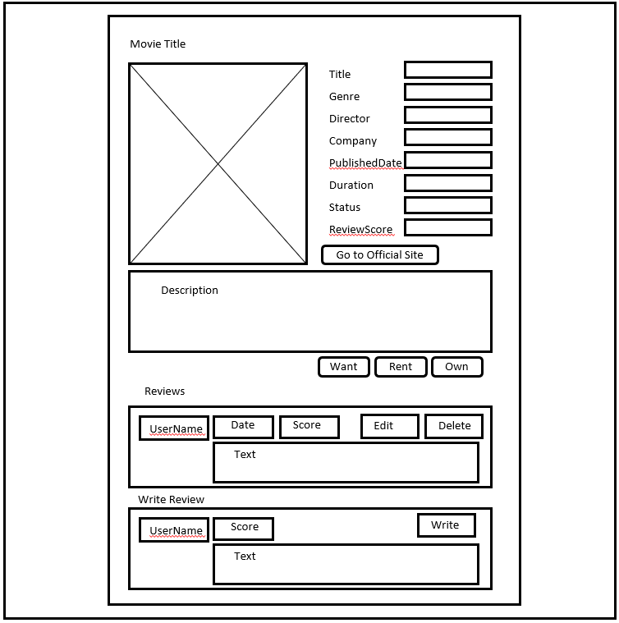

MovieAddition Page

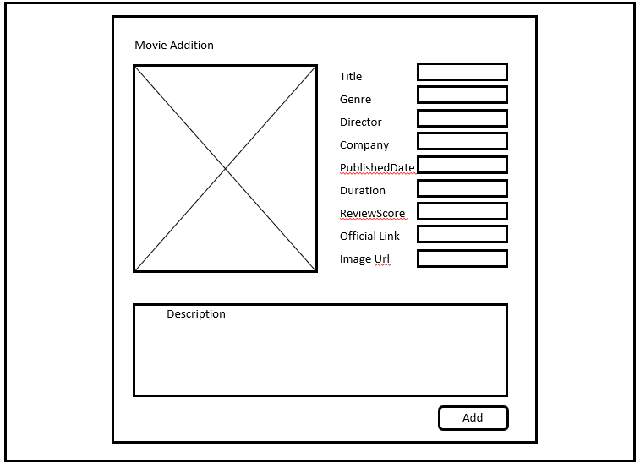

Registration Page

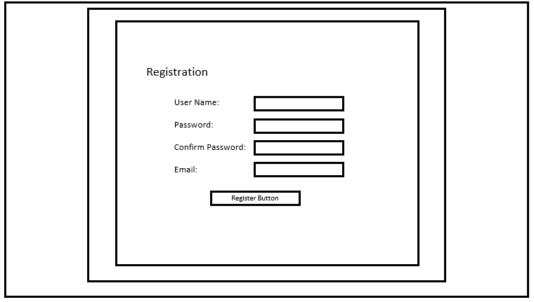

# Screen Capture Section

V0.15 Main Page elements are setup



# DB structure

